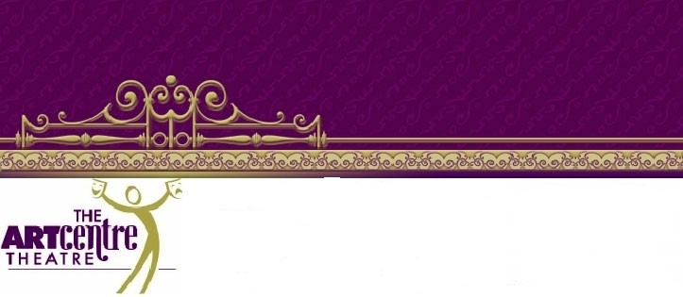
ACT Birthday Party Contract
1400 Summit Ave Suite E Plano, TX 75074
972-881-3228
ACT is a 501 C -3 nonprofit community theatre with a 90 seat auditorium. Once this contract is submitted there are no refunds or cancellations. If you wish to charge your date, there is a $50 fee to change the date and is subject to availability. If we cannot accommodate a change there will be no refunds due to cancellations by those booking the event.

Birthday Party Child and age:

Responsible Parties Names :

Primary contact number/Address/email:

Event Day(s), Date(s) & Time(s): ART PARTY / STORY DRAMA/OTHER (please circle which party you want)

Number of Children attending:

Please initial below that you understand the following:

ACT requires $100 non-refundable deposit to hold the date. Remainder of the balance is due before party begins. Please make the second check out to the instructor. Tipping your teacher is encouraged. The $200 fee only covers up to 15 children. Each additional child is $10 per guest. This includes siblings. Parents are to provide all snacks, decorations, gifts, and will clean-up unless otherwise indicated below. In the case of clean-up, this constitutes taking out trash and wiping down tables as well as sweeping up any debris left by party. If you wish to have staff handle this for you, there is a $10 cleaning charge you will need to include in your deposit check.
Also if you wish to add other services or items to your party please indicate below and add those amounts to your initial deposit check.

__________I wish to have staff handle clean up ($10 – added to my deposit check)
__________I wish to add a $50 (added to my deposit check) sheet cake to my party – this includes cake, plates, candles, matches, silverware, napkins, knife to cut. The cake will serve 15-20 persons, I understand I am to cut it myself and serve it to the children. I understand the cake will have my child’s name on it – spelled exactly as it is on this contract, however I can add whatever decorations
I prefer. (circle one) Vanilla / Chocolate
_________I wish to add $25(added to my deposit check) decorations to my party: 1 Color table-cloth, 10(2 colors) balloons, 2 colors of streamers, These will be hung prior to party and taken down by staff - Please indicate colors _____________-_________________
________I wish to add $25 (added to my deposit check) snack and drinks and supplies for the party. Said snacks will be juice boxes and water and pre-packaged snack crackers or cookies.

I UNDERSTAND AGREE TO ALL THE ABOVE STIPULATIONS AND SPECIFICATIONS. __________________________

